Lab 3

Title:
To develop a multimedia webpage using HTML elements: audio, video, images, links, iframes

1. Objective:
The objective of this lab work is to design and develop a multimedia web page using HTML. This lab focuses on the use of multimedia elements such as images, audio, video, hyperlinks, and iframes to embed external content within a webpage.

2. Tools / Software Used:
- Operating System: Windows / Linux / macOS
- Text Editor: VS Code / Notepad++
- Web Browser: Google Chrome / Mozilla Firefox

3. Theory:
Multimedia web pages contain different types of media elements such as text, images, audio, video, and embedded external content. HTML provides specific tags to handle multimedia:
- <img> is used to display images.
- <audio> is used to play audio files.
- <video> is used to play video files.
- <a> is used to create hyperlinks.
- <iframe> is used to embed external web pages or videos such as YouTube.
CSS is used to style and arrange these elements properly. In this lab, internal CSS is used to design the navigation bar and control the layout of multimedia elements.

4. Algorithm / Procedure:
- Create a new HTML file.
- Define the basic HTML structure.
- Add internal CSS for layout and styling.
- Create a navigation bar using anchor tags.
- Insert images using the <img> tag.
- Add audio using the <audio> element with controls.
- Embed video files using the <video> element.
- Embed a YouTube video using the <iframe> element.
- Save the file and open it in a web browser.

5. Source Code:

<html>
<head>
<meta charset="UTF-8">
<meta name="viewport" content="width=device-width, initial-scale=1.0">
<title>Multimedia</title>

<style>
header, main {
max-width: 850px;
margin: auto;
}
nav {
background: rgb(69, 69, 69);
display: flex;
}
nav a {
text-decoration: none;
/* background-color: green; */
color: white;
padding: 15px 30px;
font-size: 20px;
}
nav a:hover {
background-color: green;
}
img, video{
width: 250px;
margin: 10px;
}
</style>
</head>

<body>
<header>
<nav>
<a href="https:\\youtube.com" target="_blank">Youtube</a>
<a href="https:\\facebook.com" target="_blank">facebook</a>
<a href="https:\\google.com" target="_blank">Google</a>
</nav>
</header>
<main>
<section>
<h2>PNC Images</h2>
<div>
<img src="https://portal.tu.edu.np/medias/AdministrativeBuildingPNC_2024_05_16_13_27_01.jpg" alt="">
<img src="https://i0.wp.com/www.bbscollegenepal.com/wp-content/uploads/2022/05/prithvi-narayan-campus.jpg" alt="">
<img src="https://portal.tu.edu.np/medias/AdministrativeBuildingPNC_2024_05_16_13_27_01.jpg" alt="">
</div>
</section>
<section>
<h2>Maski Maski Song...</h2>
<audio src="Maski Maski.mp3" controls></audio>
</section>
<section>
<h2>Funny Video</h2>
<div>
<video src="https://videos.pexels.com/video-files/855029/855029-hd_1920_1080_30fps.mp4" controls></video>
<video src="https://videos.pexels.com/video-files/3181206/3181206-hd_1920_1080_30fps.mp4" controls></video>
<video src="https://videos.pexels.com/video-files/4874384/4874384-uhd_2560_1440_30fps.mp4" controls></video>
</div>
</section>
<section>
<h2>Not Your Type Youtube Video</h2>
<div>
<iframe width="535" height="300" src="https://www.youtube.com/embed/SRGfm8u-Yqs" title="Desi Friends With Benefits | Ep 1" frameborder="0 allowfullscreen></iframe>
</div>
</section>
</main>
</body>
</html>
Screenshort:
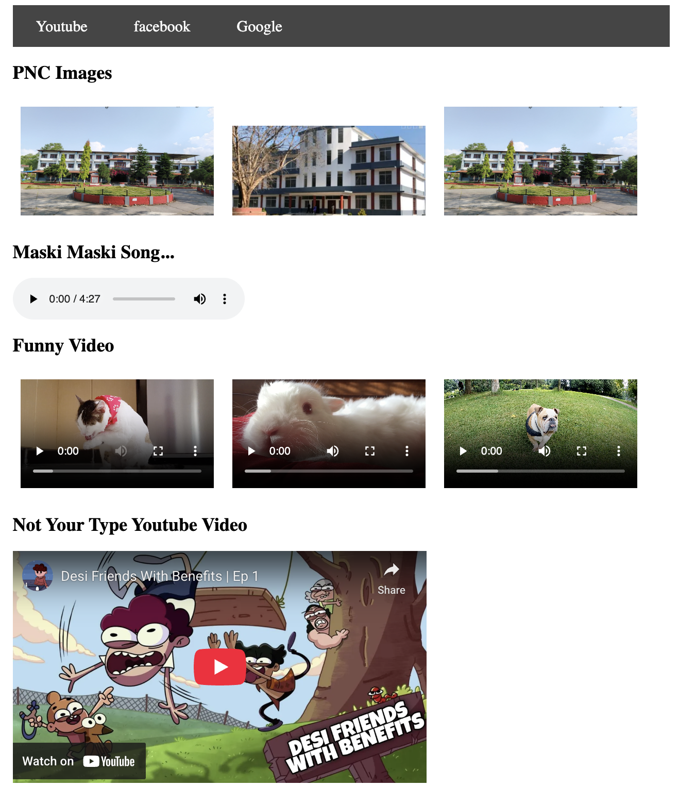

6. Output:
The output is a multimedia web page displayed in a browser containing a navigation bar with external links, campus images, an audio player, multiple video players, and an embedded YouTube video using iframe.

7. Conclusion:
In this lab work, a multimedia webpage was successfully developed using HTML multimedia elements. The use of images, audio, video, links, and iframe enhanced the interactivity of the webpage. This lab helped in understanding how different multimedia components can be integrated into a single web page using HTML.
Print Below pages….

5. Source Code:

<html>
<head>
<meta charset="UTF-8">
<meta name="viewport" content="width=device-width, initial-scale=1.0">
<title>Multimedia</title>

<style>
header, main {
max-width: 850px;
margin: auto;
}
nav {
background: rgb(69, 69, 69);
display: flex;
}
nav a {
text-decoration: none;
/* background-color: green; */
color: white;
padding: 15px 30px;
font-size: 20px;
}
nav a:hover {
background-color: green;
}
img, video{
width: 250px;
margin: 10px;
}
</style>
</head>

<body>
<header>
<nav>
<a href="https:\\youtube.com" target="_blank">Youtube</a>
<a href="https:\\facebook.com" target="_blank">facebook</a>
<a href="https:\\google.com" target="_blank">Google</a>
</nav>
</header>
<main>
<section>
<h2>PNC Images</h2>
<div>
<img src="https://portal.tu.edu.np/medias/AdministrativeBuildingPNC_2024_05_16_13_27_01.jpg" alt="">
<img src="https://i0.wp.com/www.bbscollegenepal.com/wp-content/uploads/2022/05/prithvi-narayan-campus.jpg" alt="">
<img src="https://portal.tu.edu.np/medias/AdministrativeBuildingPNC_2024_05_16_13_27_01.jpg" alt="">
</div>
</section>
<section>
<h2>Maski Maski Song...</h2>
<audio src="Maski Maski.mp3" controls></audio>
</section>
<section>
<h2>Funny Video</h2>
<div>
<video src="https://videos.pexels.com/video-files/855029/855029-hd_1920_1080_30fps.mp4" controls></video>
<video src="https://videos.pexels.com/video-files/3181206/3181206-hd_1920_1080_30fps.mp4" controls></video>
<video src="https://videos.pexels.com/video-files/4874384/4874384-uhd_2560_1440_30fps.mp4" controls></video>
</div>
</section>
<section>
<h2>Not Your Type Youtube Video</h2>
<div>
<iframe width="535" height="300" src="https://www.youtube.com/embed/SRGfm8u-Yqs" title="Desi Friends With Benefits | Ep 1" frameborder="0 allowfullscreen></iframe>
</div>
</section>
</main>
</body>
</html>
Screenshort:


